**Lab3: “Bring Your Own Script” A YOLOv3 Object Detector on GluonCV and SageMaker**

1. **Launch** the lab3 Jupyter notbook from your instance.

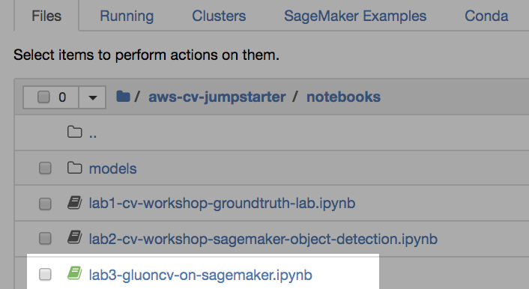

1. **Follow the notebook’s instructions**, and have fun!